

Anatolian Rover Challenge 2025

**Science Report**

**Updated Due Date: 1st June 2025**

Team Name :

University :

**Table of Contents**

General Needs and Information 3

Background of the Science Team Members 3

Geomorphology of the Mars Field 3

The Preferred Landing Site 3

Scientific Hypothesis Definition 4

Approach to Investigate the Hypothesis 4

Sampling System Description 4

Equipment and Reagents 5

Sketch 5

References 5

The Sketch of the Mars Field 6

# General Needs and Information

* Any information not provided by the science team members should be properly cited. The 7th edition of the APA style guide is recommended. Rather than using websites, please refer to relevant papers or books.
* The report must be a maximum of 4 pages long in total.
* The **Science Report** will not be scored individually for the ARC 2025. The points of Science Mission will be affected by this report. Information given in this report and data collected throughout the mission will be discussed with the judges.

# Background of the Science Team Members

A paragraph about the team's history, attended competitions and experience should be written. A table of active members including the following information should be given: Team member name, university major, and duty in the team.

# Geomorphology of the Mars Field

A brief overview of the geological features of the area from the given sketch should be made. The geological features are examined in terms of what they are, how they have formed, and how they are related to each other based on the formation time. Geological units and their relationship should be described briefly based on the given Mars coordinates and the sketch*.

*Do not forget to check out the details of Solis Planum (33°S, 271°E)and Mawrth Vallis (22.3°N, 343.5°E) from the literature. There may be additional geological structures that are not included in the sketch that can help your hypothesis. It is encouraged to support your hypothesis with additional images gathered from orbiter data such as HRSC, MOLA, HIRISE, CTX, etc.

# The Preferred Landing Site

The landing area should be justified in accordance with the scientific hypothesis. Besides, the landing site should be a suitable terrain for the rover to land. The teams should provide sufficient explanations for both aspects of the landing site: consistency for the scientific hypothesis and safe landing conditions.

The landing site where the teams start Mission 1 should be shown on the sketch of the challenge area.

# Scientific Hypothesis Definition

An overview of the hypothesis, indicating which feature will be studied and what question will be asked, should be written first.

A scientific question of the hypothesis should be defined based on the given sketch of the designated area and selected locations on Solis Planum (33°S, 271°E) or Mawrth Vallis (22.3°N, 343.5°E). Teams should explain which feature(s) they are planning to work for the hypothesis.

An important note is that this will be the final version of your hypothesis. During the competitions, the hypothesis stated in the **Science Report** mustbe followed.

# Approach to Investigate the Hypothesis

Teams are expected to confirm or reject their hypothesis by conducting experiments or analyzing geology. Any method to acquire the necessary knowledge for verifying the scientific hypothesis should be introduced in this section. Teams are expected to convince the judges of the suitability of their way of testing the hypothesis and reaching a conclusion from the data obtained. How the selected methods and experiments may help to reject or confirm the hypothesis should be discussed. The experiments selected to verify the hypothesis and the reasons why that method was chosen should be explained. Methods used should have geological and/or biological importance, such as determining a property of the geological feature or the existence of life.

The experiments planned to perform on the sample, and the expected result after these experiments should be clearly stated. This part should cover the importance of the sample to test the hypothesis. Teams should show the consistency of the experiments with the hypothesis. The location of the sampling site should be indicated precisely on the sketch.

Each sensor that will be used should be explained briefly. The purpose of using the selected sensors and data that will be gathered need to be stated.

Note that any other data not gathered by the team during the mission will not be accepted. In addition, randomized experiments that do not contribute to the scientific hypothesis will not yield scores.

# Sampling System Description

The teams should explain their sampling approach for the sampling system and insulated container. How are the samples prevented from being exposed to the environment and avoided contamination? Is there an innovative approach developed to prevent contamination?

# Equipment and Reagents

The safety levels of each reagent that will be used and which experiment that reagent is used in should be indicated. A table containing the experiment name, reagent name, the amount of reagent, level of hazard, safety procedure, and disposal procedure should be constructed for each reagent. Apart from these headings, additional information can be given Safety Data Sheets (SDS) of reagents that are obtained from providers should be used and added as links to the table if available. Note that the improper use or disposal of reagents without adapting the necessary safety measures will result in the restriction of their use.

Please refer to the rules in Part 2: Laboratory section on the ARC’25 Manual Version 3 while designing your experiment.

# Sketch

The provided sketch of the Mars field should be used to show the site **where the hypothesis will be tested**, the **landing site,** and the **sampling site(s)**. Arrows, dashed lines, or any other straightforward way can be used to show the sites that teams are concerned about. A proper legend is necessary for the judges to understand these selected sites by teams. Please identify the structures in the sketch. If you are not sure about the structure to identify, interpretation will be awarded as well. The updated sketch by the teams should be added to this document. It is encouraged you to provide a satellite image together with the updated sketch of the area, and indicate the matched structures provided in the sketch.

# The Sketch of the Mars Field

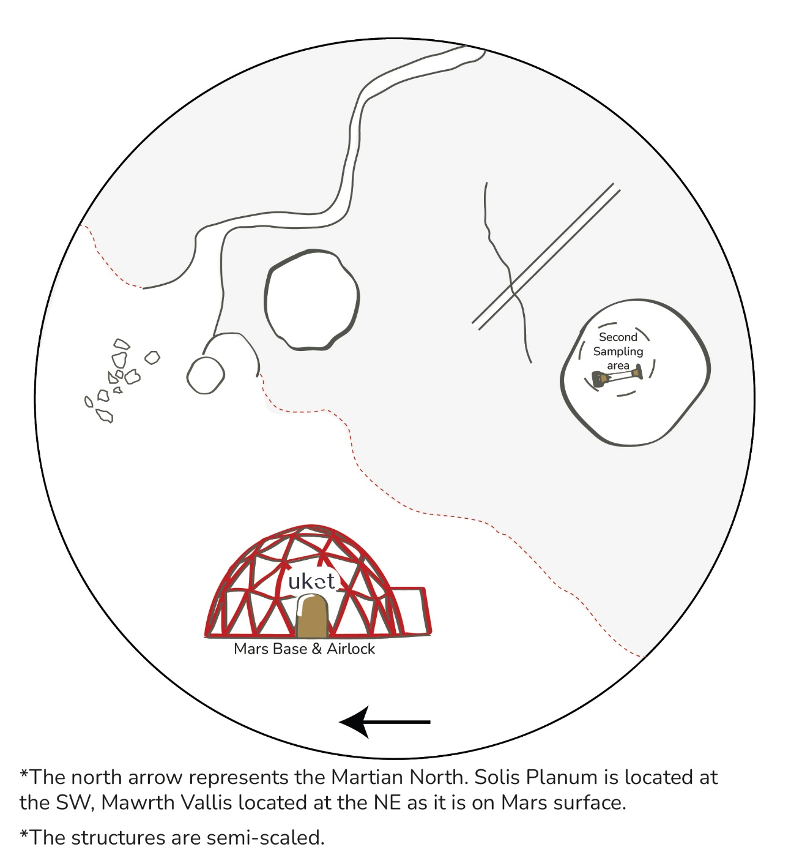

# References

Sources used throughout the report should be properly cited by using APA 7th format.